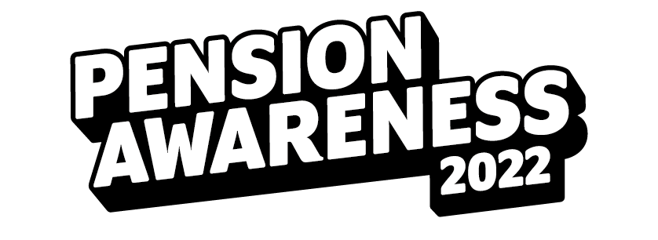

How do I get pension-savvy?

Knowing exactly what’s going on with your pension and getting a handle on how pensions work is important. But how do you do it? How do you set up the future you want without feeling baffled? That’s where Pension Awareness comes in.

Pension Awareness is the creation of savings crusaders Pension Geeks, a team standing up against complex and complicated jargon - and giving you the knowledge you need to turn the screw with your pension.

From the 12th to the 16th September, Pension Awareness returns with an online event to break down traditional pension and money topics in digestible and non-scary ways to help you secure your retirement.

The event will take the form of live TV shows, tackling the biggest pension questions, such as Pension 101, combining pots and the State Pension. Plus, there will be lively Q&As with the expert team, as well as handy videos, articles and helpful resources to give you the tools you need to grow your pension your way.

And Pension Awareness is about so much more than pensions. It’s about mindful money, budgeting hacks and your overall financial wellbeing. There’s something for everyone.

So, take that extra step with Pension Awareness, and pay your pension some attention!

Check out the week’s schedule of live shows here, or get a head start by exploring the knowledge centre, full of practical videos, articles and resources.

You can find all of this, and much more, at www.pensionawarenessday.com

